QUICK HELP - CUSTOMER ADDRESSBOOK

REQUIREMENTS

- Address book: get a record of all contacts information for all of our customers
- Extranet user database: to upgrade a contact from the address book to a extranet user
- CRT & Roles system: to link this contact or extranet user to BAAN

STRUCTURE & FIELD KEYS

- Address book

Address Book Contact

Name
Lastname
Company
Phone
Email

Etc…

- Extranet User

Address Book Contact

+ Userid
+ Password
+ enable
+ type
Address Book Contact

Name
Lastname
Company
Phone
Email

Etc…

WARNING: This information will only allow the user to login; all features could not be available without configuring/linking the customer name.

- CRT & Roles

BAAN keys to get customer information in BAAN
- Customer number (cuno#)
- Company number (erp#)

PROBLEMS:
- How to link the extranet user or contact to BAAN?
- Who are the representatives for this contact?
- What are the default locations?
- Configure the contact to receive an automatic notification?
- Make notifications flexible?
- Know the default address for delivery, billing etc.?

BAAN Customer

Customer name
Cuno#

Etc.
Address Book Contact
+
Extranet User
?????
Intranet Customer

Customer name
Type

Etc.
SOLUTION:
- How to link the extranet user or contact to BAAN? CRT
- Who are the representatives for this contact? CRT
- What are the default locations? CRT
- Configure the contact to receive an automatic notification? CRT + ROLES
- Make notifications flexible? CRT + ROLES
- Know the default address for delivery, billing etc.? CRT + ROLES

CRT STRUCTURE:

CRT = Customer Relationship Team
Module located under SALES >> CRT

Intranet Customer

Customer name
Type

CRT

Customer intranet name
Cuno#
Company#
Reps list
Locations list
BAAN Customer

Customer name
Cuno#

As you can see in the CRT we have the Cuno# and the Company#, so now we will be able to link the intranet customer to BAAN with CRT datas.

ALL together:
BAAN Customer

Customer name
Cuno#

Etc.

Address Book Contact
Intranet Customer

Customer name
Type

Etc.
SPECIAL TABLE

CRT
Roles
Address

CRT
BAAN

MODULE

To access the extranet user or customer address book module, go to SALES/Extranet User.

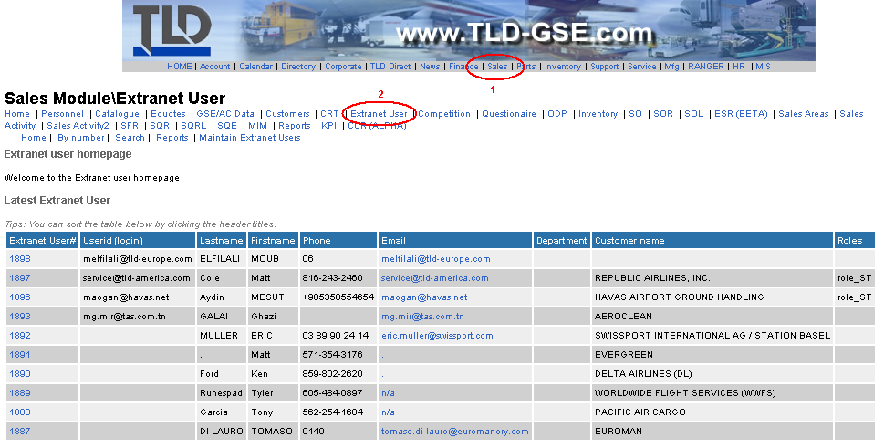

CREATE ACCOUNT

- Create user

To create an entry, click ‘Maintain Extranet Users’ as bellow to enter the admin mode.
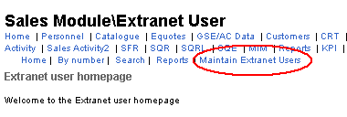
Once into the admin mode, proceed like all other module to create an entry, click ‘add’
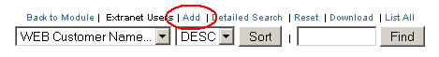
Now you have the form, fill in all information needed and submit.

Then go back to module, the general page of the entry newly created, to assign a CRT and role to the contact.

Summary:

Extranet adressbook module
Create contact
Link CRT + Roles
END
Add multiple
CRT ?
- Add CRT and roles

What is a CRT?

The CRT or Customer Relationship Team describes the TLD team and misc information for a customer. A CRT will allow us to know for instance:
- What is the parts representative of the customer FEDEX?
- What is the service location for the customer AIR FRANCE?
- What are the customers that have the ASM X as a sales rep?
With this powerful data, we are also able to link any Baan documents or data to a customer contact.

What are the roles? What is a Flaf (fl)

Roles describe the way we can split the access to EXTRANET for a contact.
For now, 3 roles have been created:
- role_buyer Buyer to receive Order Ack and Packing slip
- role_AP Account Payable to receive Invoices
- role_ST Service Technician to receive SB Notifications

Flat is a way we can split the type of Baan documents to send to the contact.
For now, 4 Flag (fl) have been created:
fl_NO_SB_NOT Do not send SN Notification
fl_NOT_SPR_INV Contact will receive invoice automatically by email
fl_NOT_SPR_ORDER_ACK Contact will receive Sale order Acknowledgement
fl_NOT_SPR_PS Contact will receive Packing slip and tracking

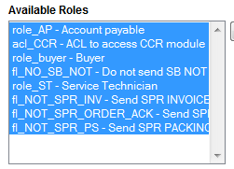

How to setup CRT and roles?

Once you are in the general page of your contact, click on CRT & roles link as bellow:
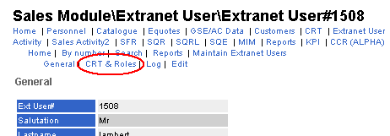

Then, 2 scenarios may happen.
Let’s say you want to link user#1508 to customer AIR FRANCE

SOLUTION – 1

Step A)

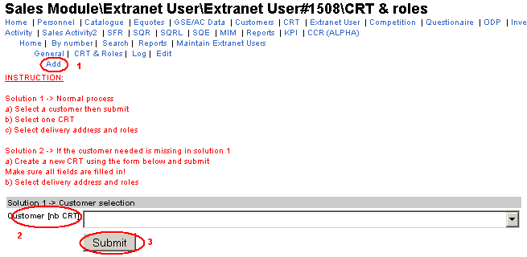

- click add
- select customer
- submit

Step B)
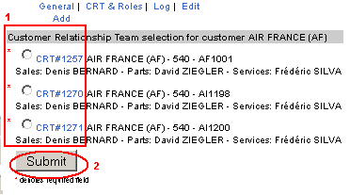

- Select CRT
- Submit

Step C)

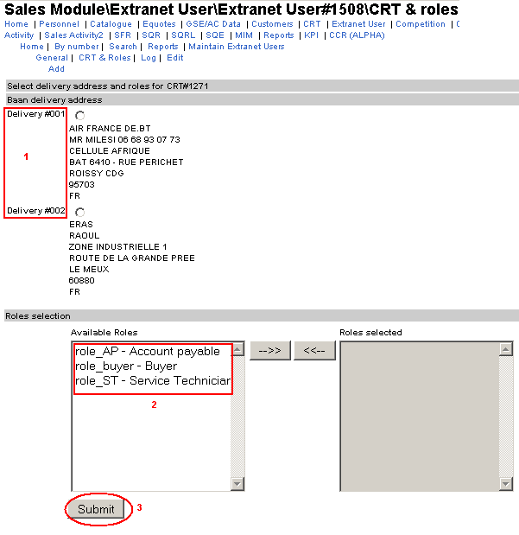
- Select the address (optional)
- Select roles
- Submit

Note: The type of address will be related to the role.
If you choose the role Buyer, then the address would be the delivery address.
If you choose the role Account Payable, then the address would be the billing address.
And so on…

SOLUTION 2:

Solution 2 may happens because you have not found the customer name you wanted into the solution 1. That means no CRT has been created for this customer, so you will need to create a CRT first as bellow:

Step A)
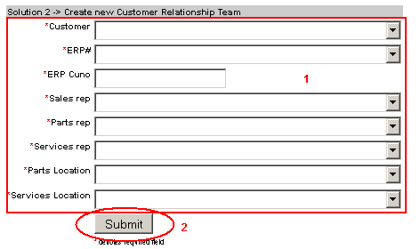
- Fill in the form
- Submit

NOTE:

If again the customer is not listed into the customer select field, you will need to ask the Sales Admin Department to create a new Intranet customer.
Once its done, go back to the solution 2 and create the CRT (step A of solution 2)

Step B)

Then here you are basically on the step C) of the solution 1.
- Select the address (optional)
- Select roles
- Submit

Finally when Solution 1 or 2 are finished, you should have linked the customer Air France with the CRT to the contact like bellow:

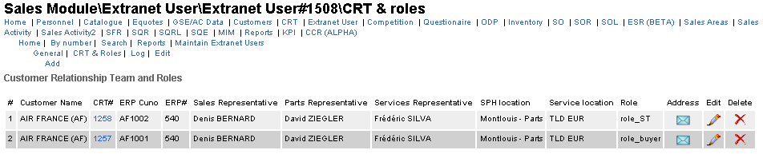

NOTE:

You will still be able to update the delivery and the role once you have created an entry. But if you choose the wrong CRT from the beginning, you will need to delete the line concerned under the CRT & Roles section (like bellow).

Summary:

CRT & Role section
Add
END
Is customer listed ?
Select customer
Select CRT
Select Address
+ Roles
Create CRT
SOLUTION 1
SOLUTION 2
yes
no
Is customer listed in the form ?
no
Ask Sales Admin to create new Customer in Intranet
Submit form
yes

Upgrade the contact to a extranet user:

The contact, in person, will need to go to the www.tld-gse.com partner section to submit a request. Then a sequence will be created to MIS and will go through approval to Sales Admin, EVP and the Chief Executive Officer of TLD. Once approved, an email with all details will be sent to this person.

